Interreg VI-A Romania-Bulgaria Programme

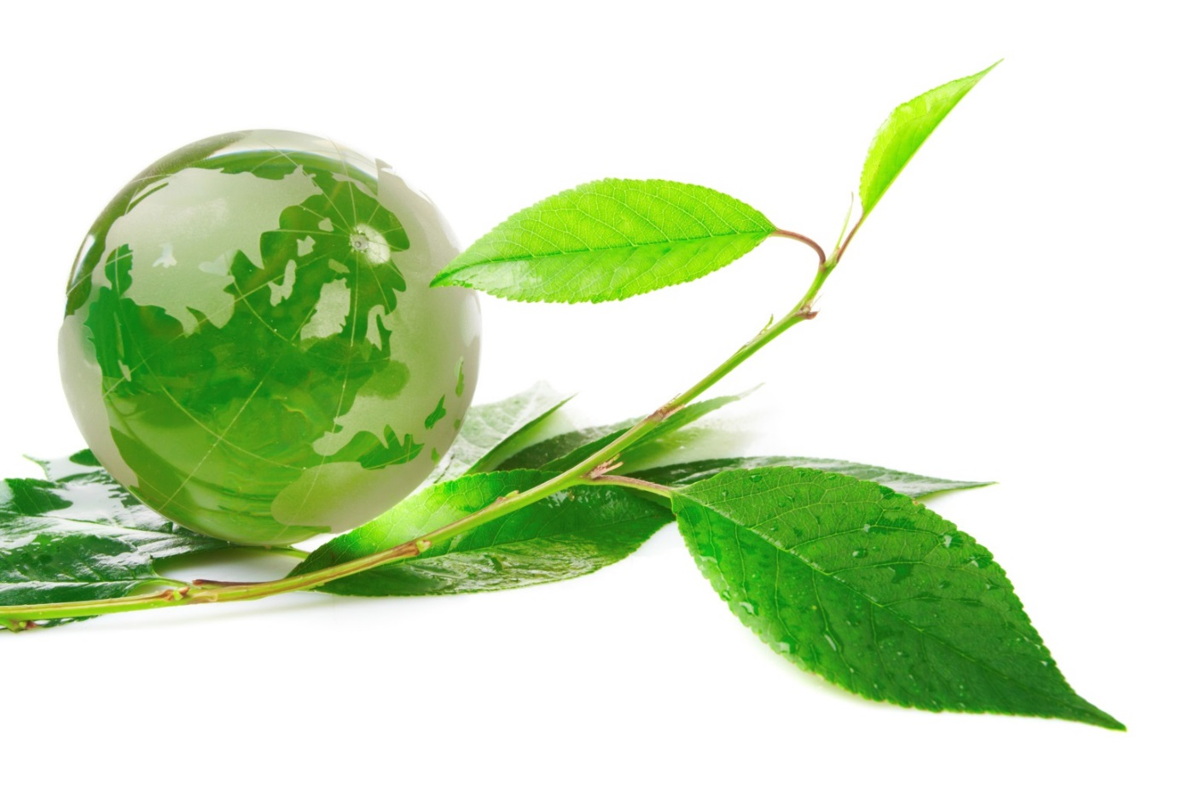

Dare to go green!

FOREWORD
Why to go green?

When it comes to the future of our planet, the policy of being too cautious is riskiest of all.
This is why one of our first actions was to launch the European Green Deal. At the heart of it is the goal to make Europe the first climate neutral continent by 2050.
This is of course about bringing nature back in our lives and cutting emissions. But the European Green Deal is more than that – it is our new growth strategy. It will give investors certainty and help our economies grow in a way that gives more back to people, to the planet and to society than it takes away.
Ursula von der Leyen, President of the European Commission

Currently we are facing the threat of climate change and environmental degradation. This threat is real and challenges both European Union as well as the entire world.
Even if the European Union is already making progress on tackling climate change, there is still room for improvement. In the last two decades, the greenhouse gas emissions decreased by 23%, while the economy grew by 61%. However, current policies will only reduce greenhouse gas emissions by 60% by 2050. In this context, in December, 2019, the European Green Deal was delivered to EU citizens. The aim of this deal is to transform the EU into a modern resource-efficient and competitive economy where:
- there are no net emissions of greenhouse gases by 2050,
- economic growth is decoupled from resource use,
- no person and no place is left behind.
In this regard, we are joining the efforts of the European Commission to contribute to the highest goal in the environmental field of the European continent: Striving to be the first climate-neutral continent!
The aim of this document is to provide a list of actions that may help you to become green, both within your project, and during your day-to-day life (in your office or at home). This document is not exhaustive and it can be completed with your own ideas (which we encourage you to share with us at robg@mdlpa.ro).
Also, this document is useful for you when designing your applications for Interreg VI-A Romania-Bulgaria Programme, as additional points shall be granted for your proposed green actions.
ACTIONS
How to go green?
What can you do within your project?
When designing and implementing your project, you can act in many ways to reduce your impact on the environment, from printing less, to green procurement or walking on foot.
Here are some tips you can follow:

Go paperless or if you really have to use paper, make it recycled one
Most of the documents might be signed electronically (you can purchase electronic signature from the lump sum for project preparation) and send them via our electronic monitoring system. Also, you may use the digital version of the documents (pdfs) instead of copying them.
In terms of promoting the project, we also encourage going online. Using the brochures, flyers and other printed promotional materials have to be well justified.
However, we are not know-it-alls. In case you do have to use paper to print something, use recycled paper and/or use the both sides of the paper sheets. It’s a well-known way to conserve resources. Most providers offer an option to supply you with recycled paper.

Use the Programme electronic system and e-mail for communicating with the Programme structures or your project partners
The communication related to the project implementation will be in electronic format, starting with the application submissions to the project implementation and project closure. The JeMS will help us all.
All the documents will be filled in, submitted and approved in the electronic system.
We shall communicate with you mostly via electronic system, and we encourage you to use the same method, including when communicating with your partners.
Of course, you can reach us also using the phone or email. All these data are available on our website, or will be provided to you when signing the financing contracts (your project manager shall be close to you during the entire implementation period).

Switch to cloud computing
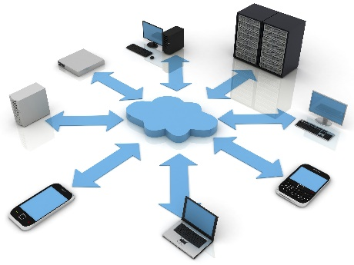 | Cloud computing formats like Google Apps, Apple iCloud, and Microsoft Office 365 / similar allow you, your staff and your project partners to share and access information from anywhere, and can reduce the travel costs, carbon emissions, and printing costs of your project.  As project information/documents, where not in JeMS, is hosted in the cloud, there is no need for your project to purchase and maintain expensive, power-intensive servers.
Meet online your partners
When it is possible you could meet online your partners. There are many free of charge or paid platforms that are offering you the possibility to organize online conferences with multiple audience, such as skype, zoom.us etc. Such expenditures are eligible from the flat rate for administrative costs (for which no support documents are necessary).
In this way you can reduce unnecessary travels by car or by plane to different meetings/project meetings.

Modernize your equipment
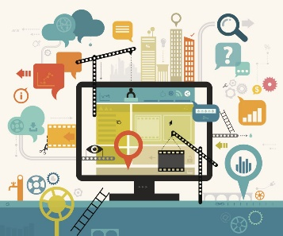 | If you’ve been in project implementation filed for a while, your equipment might be a bit outdated. While this might not seem like that big of a deal, updating and upgrading your equipment can make a significant difference in how eco-friendly you are.  Thus, use your funds allocated through the project wisely and don’t forget to buy green! Focus on energy efficient models of equipment (look for the “energy star” label). Research whether you can sign up for local renewable energy from your utility company.

Buying green (green procurement)
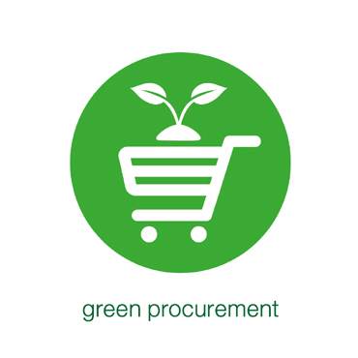 | One of the best ways to make your project more environmentally-friendly is to practice green procurement. This involves sourcing goods and services that are produced and supplied in a sustainable way. Sourcing, when possible, from local suppliers rather than those located far away is a good place to start.  When you procure goods/services, pay attention to the following aspects or review your procurement policies:  - Are manufactured in a sustainable fashion  - Do not contain toxic materials or ozone-depleting substances  - Can be recycled and/or are produced from recycled materials  - Are made from renewable materials  - Do not make use of excessive packaging  - Are designed to be repairable and not throwaway  Examples of green contracts:  - Energy efficient computers  - Office furniture from sustainable timber  - Low energy buildings  - Recycled paper  - Cleaning services using ecologically sound products  - Electric, hybrid or low-emission vehicles  - Electricity from renewable energy sources  For more details regarding green procurement you can check the European Union site: https://ec.europa.eu/environment/gpp/index_en.htm.

Operate fuel efficient vehicles (electric or hybrid cars)
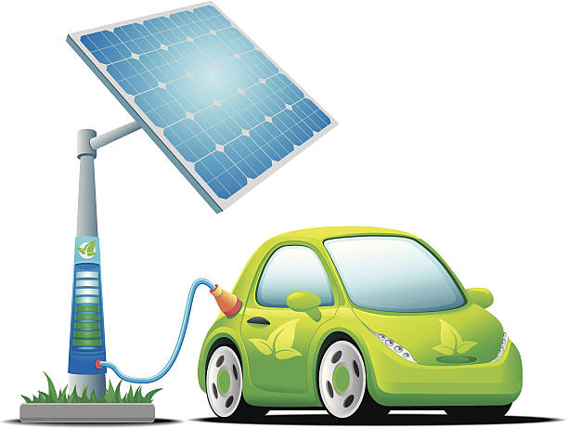 | The vehicles you use within your project have a big impact on environment.  Operating hybrid or electric vehicles for your project not only save your money in gas expense, but will send a clear message that your project is also eco-friendly. Be sure to include your green messages and/or logos on your vehicle car graphics and branding.  Check our eligibility rules when designing your project regarding the purchase of hybrid or electric vehicles vs. vehicles on fossil fuel. As a matter of fact, in case you need a vehicle from our Programme and it is not going to be electric or at least hybrid, you will need to tell us why. Without a good motivation, we won’t be convinced.

Use eco-friendly means of transport or go on foot
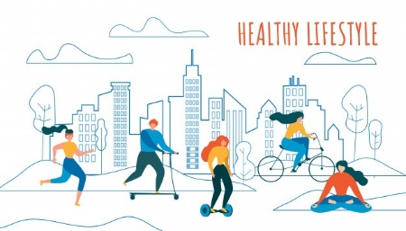 | We encourage you to use eco-friendly means of transport such as: bicycles, kick scooter, public transport, trains or boats, not only when you implement your project, but also during your day-to-day life.  Also, going on foot is a healthy alternative and very friendly with environment.
Plant a tree for your project
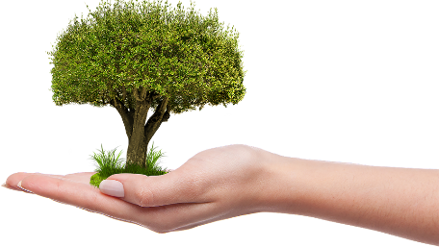 | As part of the commitment for the environment, we ask each project to give back a tree or maybe a couple more.  For each soft project, we encourage you to plant at least 2 trees, and for each investments project, at least 5, during the project implementation.  You can plant your trees on public spaces or near to your headquarters. When selecting the trees, please make sure you have chosen local species (please do not use alien and invasive species).  Also, any expenditure you might have can be budgeted under the informantion and communication activities, as we plan to promote your project and our initiative.
Work from home (teleworking) or flexitime!
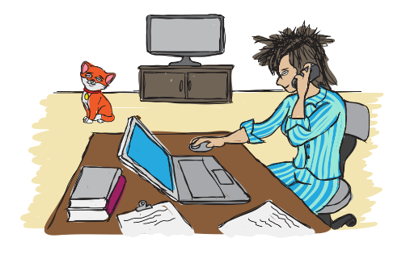 | You could consider working from home (teleworking) for you and your staff; or you could also be flexible with your working time – flexitime. Thus, you would create a balance between work, family and environment: you will not spend time in traffic (if you go flexitime, you could go to work when is no traffic jam) and would reduce your carbon print; the spare time you could spend with your family or hobbies.  In this way, both you and the environment would gain: time, fresh air and low carbon emissions.  Still, you are obliged to provide an adequate space for hosting the monitoring visits and other visits related to the project implementation and progress.

Other environmental activities
Different events/measures for protection the environment can be organized by you:
- placing hollows for animals and birds,
- cleaning different areas,
- use green alternatives to conventional building materials for insulation, structural components, flooring and etc. about the envisaged construction works in the projects,
- to be envisaged at least once per project: to clean up a local stream, park, beach etc.
- The list is open, you can take any action that will green your project!

"Move fast, build to last: Europe's new generation" - op-ed by Ursula von der Leyen, President of the European Commission, https://ec.europa.eu/commission/presscorner/detail/en/AC_20_417
According to The EU’s track record on climate action, https://ec.europa.eu/commission/presscorner/detail/en/fs_19_6720
For additional information, please check the Applicant’s Pack

